 Kehelland School Feedback and Marking Approach

Our policy is underpinned by the evidence of best practice from the Education Endowment Foundation and other expert organisations. The Education Endowment Foundation research shows that effective feedback should:
- Redirect or refocus either the teacher’s or the learner’s actions to achieve a goal.
- Be specific, accurate and clear.
- Encourage and support further effort.
- Provide specific guidance on how to improve and not just tell students when they are wrong.

Traditionally, written marking in pupil’s books is seen as the sole way to feedback to children. However, this approach is not the most effective and is the most time consuming and adds significantly to teacher workload. Evidence shows that the effectiveness of written feedback is dependent on time to feedback, time for pupils to respond and the ability for pupils to understand and respond. Therefore marking in books is only a small part of the assessment and feedback process and not all books will be marked.

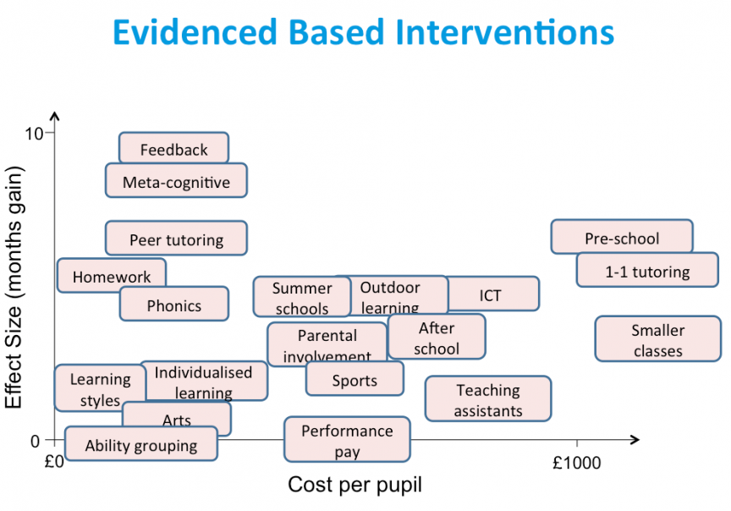

In terms of evidence-based approaches, feedback is central to an effective strategy to ensure all children make excellent progress. This approach should be looked at in conjunction with other documents that help to outline our approach – our approach to teaching and learning in lessons; minimum expectations in lessons and books; homework approach; subject leadership and curriculum planning. In foundation subjects we may ask the children to do a “show what you know” activity to support assessment and identifying gaps.

Our feedback policy has at its core a number of principles:
- The sole focus of feedback and marking should be to further children’s learning.
- Evidence of feedback and marking is incidental to the process: we do not provide additional evidence for external verification.
- Written comments should only be used when they are accessible to students according to age and ability.
- Feedback delivered closest to the point of action is most effective and as such feedback delivered during lessons is more effective than comments provided at a later date.
- Feedback is provided to pupils as part of assessment processes in the classroom and takes many forms other than written comments.
- Feedback is part of the school’s wider assessment processes, which aim to provide an appropriate level of challenge to pupils in lesson, allowing them to make good progress.
- All pupils’ work should be reviewed by teachers at the earliest appropriate opportunity so that it might impact on future learning.
- Feedback is built into every lesson as a basic part of lesson structure in all subjects.
- Assessment and feedback are used to specifically inform teaching and therefore planning to ensure gaps and misconceptions individually and in wider groups are addressed in a timely fashion.

Type | What it looks like | Examples of Evidence
Immediate | - Includes teacher gathering feedback from teaching, including whiteboards, book work etc.  - Takes place in lessons with individuals or small groups.  - Often given verbally to pupils for immediate action, may follow Plickers an low stakes quizzing.  - May involve use of a teaching assistant to provide support or further challenge.  - May re-direct the focus of teaching or the task.  - May include annotations or comments. | - Lesson observations / learning walks.  - Improvements evident in books either through editing or further working.  - Plickers and low stakes quizzing  - Pupil voice  - Lesson plans/powerpoints
Summary | - Takes place at the end of a lesson or activity.  - Often involves whole groups or classes.  - Provides an opportunity for evaluation of learning in the lesson.  - May take the form of self- or peer-assessment against an agreed set of criteria.  - In some cases, may guide a teacher’s further use of review feedback, focusing on areas of need.  - May involve 1-1 pupil conferencing | - Lesson observations / learning walks.  - Timetabled pre- and post-teaching based on assessment.  - Some evidence of self- and peer-assessment.  - May be reflected in selected focus review feedback (marking).  - Pupil conferencing notes  - Lesson plans/powerpoints
Review | - Takes place away from the point of teaching.  - May involve written comments / annotations for pupils to read / respond to.  - Provides teachers with opportunities for assessment and understanding.  - Leads to adaptation of future lessons through planning, grouping or adaptation of tasks.  - May lead to targets being set for pupils’ future attention or immediate action. | - Written comments and appropriate responses / action.  - Same day interventions.  - Adaptations to teaching sequences tasks eg revisited as the starter for the next lesson.  - Evidence of children selected for intervention following lesson in intervention records.  - Acknowledgement of completed work.
Types of feedback we use:

Marking Summary
Immediate feedback is the most effective way to move children forward and ensure good progression. Therefore we believe that this means it should, for the most part, take place in lessons. Children will mark their own learning with a different colour (purple) and they may swap books for peer marking (purple). Peer marking may lend itself to a positive comment, and an area that their friend should focus efforts on for improvement. Teachers will review books and learning as close to the lesson as possible. They may, and are encouraged to, live mark pupils work during the lesson itself using green pen.
Marking and feedback can also take place using the Ipads – verbal feedback, encouragement and celebration to move learning forward can be recorded on learning via the ipad by the teacher, and children may use this as an effective way for marking and feedback to take place.
Whole Class Feedback
In Key Stage 1 and Key Stage 2, teachers mostly review children’s learning using Whole Class Feedback. Staff use Whole Class Feedback Sheets which are retained as a record for progress and feedback. This identifies:
- work to praise and share;
- spellings which need to be followed up;
- children who need additional support on specific aspects of the learning;
- misconceptions / basic skills errors / notes for the next lesson.

The feedback is always centred on the Learning Objective for each lesson. However, writing is across the curriculum and basic skills should be supporting in every lesson. Teachers identify specific actions to help the children improve their writing.
Planning for the next lesson is then adapted to include the relevant teaching points, and these are directly linked to the Whole Class Feedback findings from the review of the previous lesson. The children’s next step is the next lesson. Pupils are given the opportunity to reflect and review or improve their work or to practise or use their new learning.
The children’s work will be stamped to show that it has been reviewed in this way. They may also use the notation VF to indicate when verbal feedback or a 1-1 conversation has taken place.
At other times, responses to a child’s writing/learning may, when appropriate, include a selection of:
- a teacher’s comment;
- the overall effectiveness of the piece
- suggestions towards how to achieve or extend aspects of the writing eg Next time…..
- positive comments or acknowledgement of a child’s work (eg sticker)

Final drafts are celebrations of work and will only be positively marked. Some final drafts will not be marked and may be used for displays etc. Marking may also take place on Ipads with children photographing work and teachers adding voice notes to specific points where celebration or feedback is needed.
Marking by other staff members
Where a supply teacher has taken a class, the expectation is that the work carried out during the period of their supervision will be marked by them prior to leaving the school. Work undertaken by a staff member covering the class may be ticked by the class teacher while undertaking marking of subsequent work.

At times, it is appropriate for Teaching Assistants to provide written feedback, for example when they are:
- Working with a child on an individual program.
- Working with an individual or a group of children on a task that requires immediate right / wrong feedback.
- Working with a child and it is appropriate that feedback is given.

Teaching Assistants always feed back to the class teacher to enable them to evaluate the learning and activity. Class teachers are always responsible for checking and monitoring the progress of any lesson not taken by them. Class teachers have overall responsibility and accountability for the progress and learning of the children in their class. This includes all children with SEND or who are educated apart or in an alternative space/on an alternative curriculum.


Kehelland School Marking Code

I | Independent work
A | Assisted by an adult
SDI | Same day intervention
VF | Verbal Feedback given
S | Spelling error
P | Punctuation error
 | Correct
 | Have another think about this
 | Come and talk to the teacher
 | Great Job
 | Something missing, take a look
 | Have a go at this

