Longships sequence of learning – PE Year B
Autumn term – orienteering
Cross-curricular orienteering Physical Education OAA Year 1
Lesson 1 | Lesson 2 | Lesson 3 | Lesson 4 | Lesson 5 | Lesson 6
Symbol map grid challenge | Letter legends | Number legends | Orienteering symbol games | Google Earth and the orienteering map 1 | Google Earth and the orienteering map 2

Autumn term – realPE
Year 2 unit 1
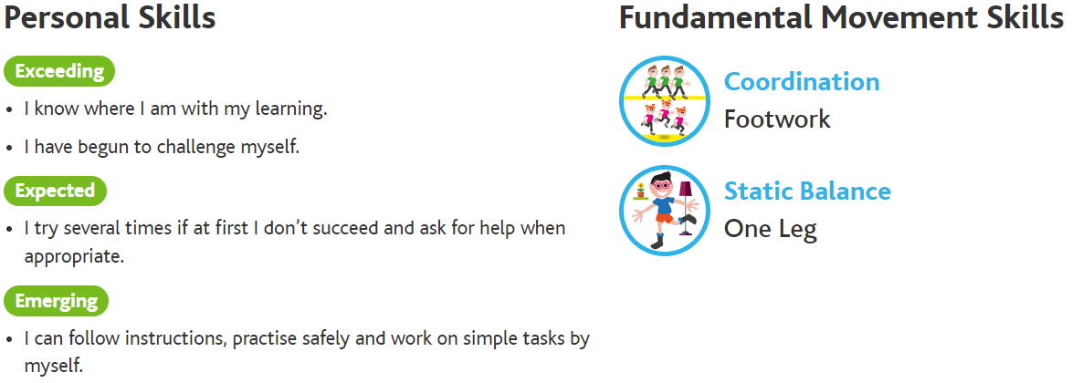
Lesson 1 | Lesson 2 | Lesson 3 | Lesson 4 | Lesson 5 | Lesson 6
Footwork – move from side to side in both directions, try to combine side steps with front pivots | Footwork – move from side to side in both directions, try to combine side steps with front pivots, hopscotch, alternating your hopping leg each time | Footwork – move from side to side in both directions, try to combine side steps with front pivots, hopscotch, alternating your hopping leg each time, move in a 3 step zigzag pattern with a knee raise across the body | One leg balance – balance of one leg, see how long you can hold your balance | One leg balance – balance of one leg, see how long you can hold your balance, close your eyes and hold your balance | One leg balance – balance of one leg, see how long you can hold your balance, close your eyes and hold your balance, try to balance on one leg on an uneven surface for 30 seconds
Year 2 unit 2
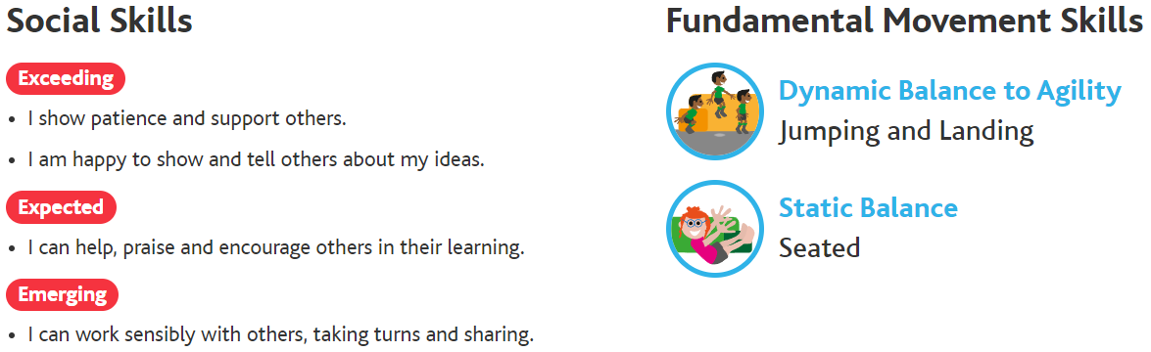
Lesson 1 | Lesson 2 | Lesson 3 | Lesson 4 | Lesson 5 | Lesson 6
Jumping and landing – jump forwards and backwards on 2 feet, jump and turn to the side | Jumping and landing – jump forwards and backwards on 2 feet, jump and turn to the side, jump and turn to face the opposite direction | Jumping and landing – jump forwards and backwards on 2 feet, jump and turn to the side, jump and turn to face the opposite direction, jump from 2 feet to 2 feet forwards and backwards landing on a line | Seated balance – sit down and hold your balance, try and move an object from one side of your body to the other | Seated balance – sit down and hold your balance, try and move an object from one side of your body to the other, try and pick up, move and place the object across your body with the same hand | Seated balance – sit down and hold your balance, try and move an object from one side of your body to the other, try and pick up, move and place the object across your body with the same hand, reach and pick up an item, swap hands and place it on the other side

Autumn term – realgym
Year 2 unit 1
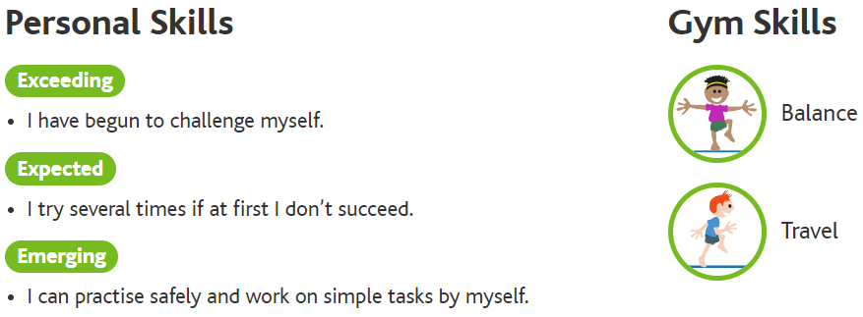
Lesson 1 | Lesson 2 | Lesson 3 | Lesson 4 | Lesson 5 | Lesson 6
Balance – floor work | Balance – low apparatus | Balance – large apparatus | Travel – floor work | Travel – low apparatus | Travel – large apparatus

