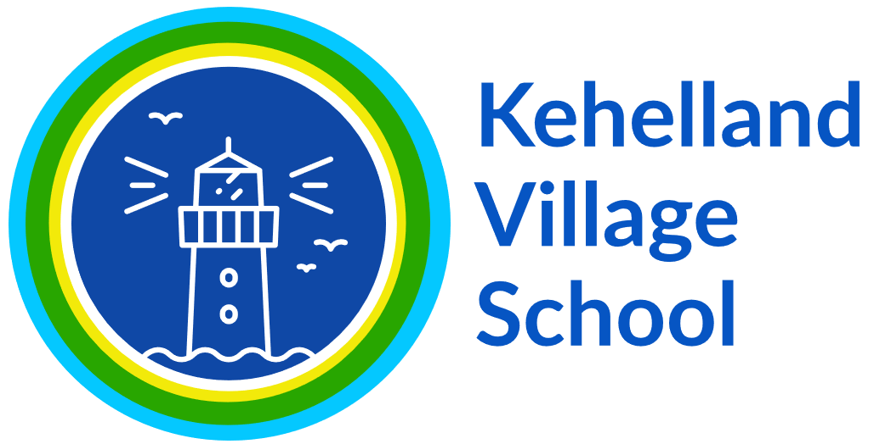

Subject Strategy Document – SCIENCE 2022-23

Statement of Intent

At Kehelland School, we recognise the importance of Science in every aspect of daily life. As one of the core subjects taught in Primary Schools, we give the teaching and learning of Science the prominence it requires.
The Scientific area of learning is concerned with increasing pupils’ knowledge and understanding of our world, and with developing skills associated with Science as a process of enquiry. It will develop the natural curiosity of the child, encourage respect for living organisms and the physical environment and provide opportunities for critical evaluation of evidence.

Statement of Implementation

At Kehelland School, we deliver weekly, 2 hour lessons in mixed aged classes in science. We follow the Grammarsaurus Science scheme, mapped in a rolling programme. This year we are transitioning from the PZAZ scheme to Grammarsaurus. Our new curriculum is more equipped and fit to ensure our children develop a love of science and are exposed to Science capital throughout their lives at Kehelland school. We currently have a two year rolling programme of study for KS1 and KS1, with a yearly programme of study for the EYFS.

Online resources we may use include:
- Pzaz which also has significant CPOD for non specialist staff
- Grammarsaurus science, which is suited to the “Kehelland Way” of teaching and learning pedagogy
- PLAN and PSEC resources to support teaching, planning and assessment
• Explorify.co.uk- An amazing website full of resources which can be used a lesson starter, conversation sparks, main activities or plenaries.
• ‘Education in Chemistry’ is also a website rich in knowledge and lesson ideas.
• TAPS assessments

We place practical science skills at the heart of our curriculum and involve as many members of our school community in our science learning as possible. We seek to make cross curricular links with other subjects and with local industries and businesses, utilising the STEM (Science, Technology, Engineering and Maths) links across learning throughout the year. We take part in workshops i.e. Explorer Dome, Fish and chip SOS (where children can have the opportunity to use equipment we cannot provide) offered by local secondary schools and also have STEM ambassadors visit and conduct practical workshops. We encourage and expect classes to have trips off site - residentials and activity weeks. For example this is visible with things such as Beach warriors week, Farm trips looking at environmental stewardship and so on and so forth.

Recording and monitoring

Each class has their own floor book where any evidence such as photo’s, examples of children’s work, children’s comments, observations and NC coverage are collated. It is expected that these floor books will follow the specific year groups through the school to show progression. The children also have their Lighthouse Learning where they will keep a record of any written work. We will assess the children either informally through questioning, discussions, observed investigations or written tests. These can be done during or at the end of each unit to assist in the monitoring process so that we can see which children are on target and which may need further support.

Statement of Impact

The successful approach at Kehelland results in a fun, engaging, high-quality science education, that provides children with the foundations for understanding the world. Our engagement with the local environment ensures that children learn through varied and first hand experiences of the world around them. So much of science lends itself to outdoor learning and so we provide children with opportunities to experience this. Through various workshops, trips and interactions with experts, children have the understanding that science has changed our lives and that it is vital to the world’s future prosperity. Children learn the possibilities for careers in science as a result of our community links and connection with national agencies such as the STEM association.

