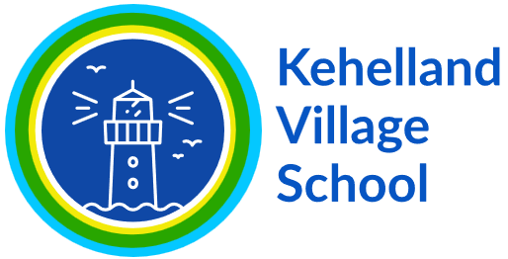
Subject Rolling Programme - DT
 | Autumn | Spring | Summer
EYFS | Junk Modelling  Structures Strand | Fruit and Vegetables – Making Soup  Nutrition Strand | Bookmarks  Materials Strand
Year 1/2 Year A | Making a Moving Book  Mechanism Strand | Sewing a Puppet  Textiles Strand | Smoothies  Nutrition Strand
Year 1/2 Year B | Build a Windmill  Structures strand | Balanced Diet - Wrap  Nutrition Strand | Wheels and Axels  Mechanism Strand
Year 3/4 Year A | Constructing a castle  Structures Strand | Pneumatic Monsters  Mechanisms Strand | Eating Seasonally – pastry tart  Nutrition Strand
Year 3/4 Year B | Bridges  Structures Strand | Pop Up Book  Mechanisms strand | What Could Be healthier? Bolognese  Nutrition Strand
Year 5/6 Year A | Adapting a recipe (biscuit/dough)  Nutrition Strand | Electrical Information Display  Electrical Systems Strand | Navigating the World  Digital World Strand
Year 5/6 Year B | Cross Stitch and Applique Cushions  Textiles strand | Playgrounds  Structures | Come Dine with Me  Nutrition Strand

