Trevose sequence of learning – DT Year B

Autumn term – Electrical systems: torches
Unit outcomes
Pupils who are secure will be able to:
- Identify electrical products and explain why they are useful.
- Help to make a working switch.
- Identify the features of a torch and how it works.
- Describe what makes a torch successful.
- Create suitable designs that fit the success criteria and their own design criteria.
- Create a functioning torch with a switch according to their design criteria.

Key vocabulary
battery  bulb  buzzer  conductor  circuit  circuit diagram  electricity  insulator |  | series circuit  switch  component  design  design criteria  diagram  evaluation  LED |  |  | model  shape  target audience  input  recyclable  theme  aesthetics |  | assemble  equipment  ingredients  packaging  properties  sketch  test
Lesson 1 | Lesson 2 |  | Lesson 3 | Lesson 4
Lesson 1: Electrical products | Lesson 2: Evaluating torches |  | Lesson 3: Torch design | Lesson 4: Torch assembly

Summer term – Mechanical systems: slingshot car
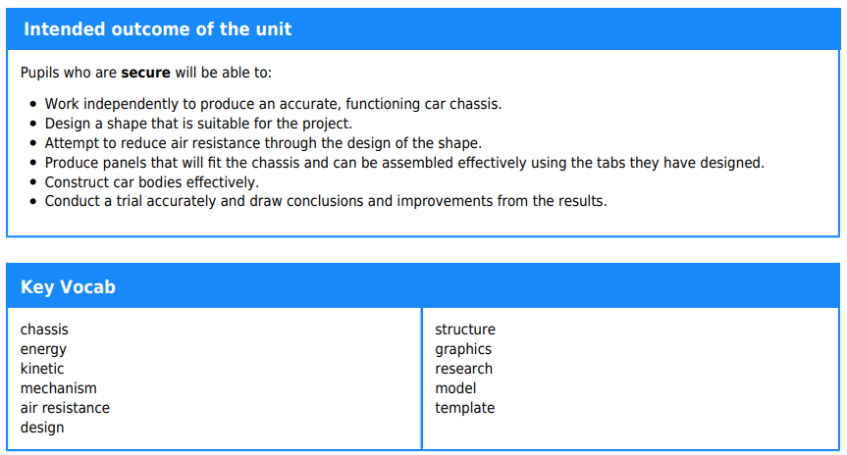
Lesson 1 | Lesson 2 | Lesson 3 | Lesson 4
Lesson 1: Chassis and launch mechanism | Lesson 2: Designing the car body | Lesson 3: Making the car body | Lesson 4: Assembly and testing

