Trevose sequence of learning – PE Year B
Autumn term – orienteering
Cross-curricular orienteering Physical Education OAA Year 3
Lesson 1 | Lesson 2 | Lesson 3 | Lesson 4 | Lesson 5 | Lesson 6
Navigate the cones 1 | Navigate the cones 2 | Setting the orienteering map 1 | Setting the orienteering map 2 | STAR orienteering | SCORE orienteering

Autumn term – realPE
Year 4 unit 1
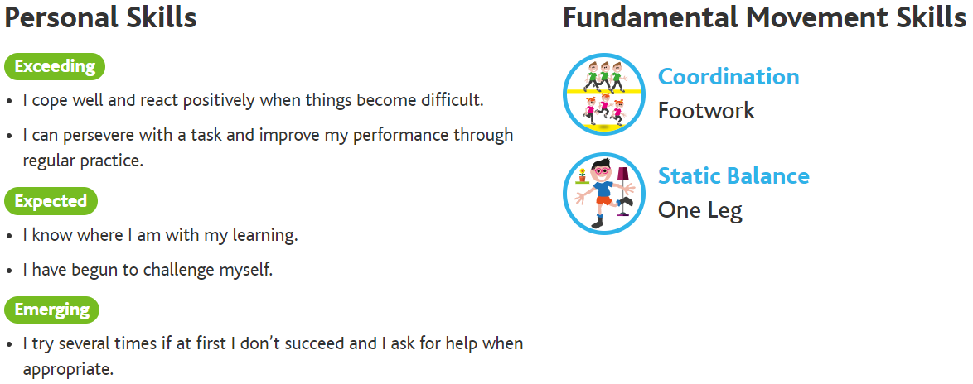

Lesson 1 | Lesson 2 | Lesson 3 | Lesson 4 | Lesson 5 | Lesson 6
Footwork – try to combine side steps with front pivots, hopscotch, alternating your hopping leg each time | Footwork – try to combine side steps with front pivots, hopscotch, alternating your hopping leg each time, move in a 3 step zigzag pattern with a knee raise across the body | Footwork – try to combine side steps with front pivots, hopscotch, alternating your hopping leg each time, move in a 3 step zigzag pattern with a knee raise across the body, move in a 3 step zigzag pattern while alternating knee raise and foot behind | One leg balance – see how long you can hold your balance, close your eyes and hold your balance | One leg balance – see how long you can hold your balance, close your eyes and hold your balance, try to balance on one leg on an uneven surface for 30 seconds | One leg balance – see how long you can hold your balance, close your eyes and hold your balance, try to balance on one leg on an uneven surface for 30 seconds, balance on an uneven surface with eyes closed

Year 4 unit 2
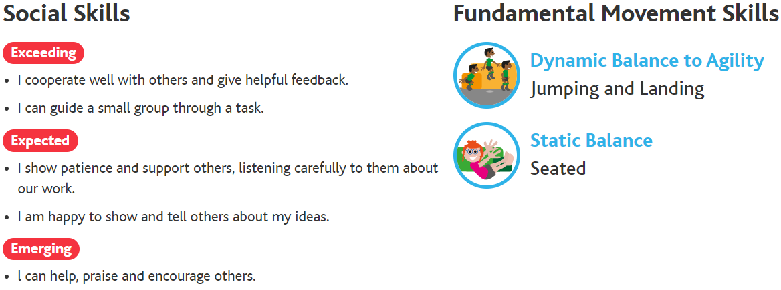
Lesson 1 | Lesson 2 | Lesson 3 | Lesson 4 | Lesson 5 | Lesson 6
Jumping and landing –jump and turn to the side, jump and turn to face the opposite direction | Jumping and landing – jump and turn to the side, jump and turn to face the opposite direction, jump from 2 feet to 2 feet forwards and backwards landing on a line | Jumping and landing – jump and turn to the side, jump and turn to face the opposite direction, jump from 2 feet to 2 feet forwards and backwards landing on a line, jump from 2 feet to 2 feet with a 180° turn and land on a line | Seated balance – try and move an object from one side of your body to the other, try and pick up, move and place the object across your body with the same hand | Seated balance – try and move an object from one side of your body to the other, try and pick up, move and place the object across your body with the same hand, , reach and pick up an item, swap hands and place it on the other side | Seated balance – try and move an object from one side of your body to the other, try and pick up, move and place the object across your body with the same hand, reach and pick up an item, swap hands and place it on the other side, reach and pick up items from in front, to the side and from behind
Autumn term – realgym
Y4 unit 1
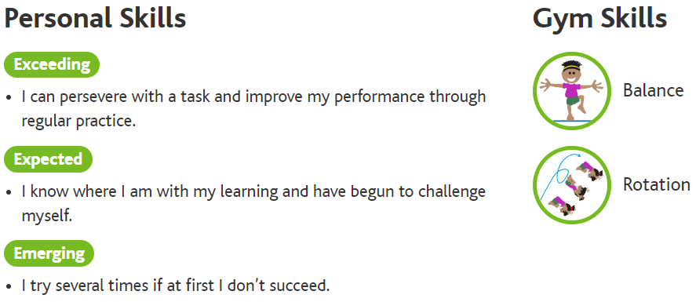

Lesson 1 | Lesson 2 | Lesson 3 | Lesson 4 | Lesson 5 | Lesson 6
Balance – partner work | Balance – partner work | Balance – partner work | Rotation – floor work | Rotation – hand apparatus | Rotation – hand apparatus

