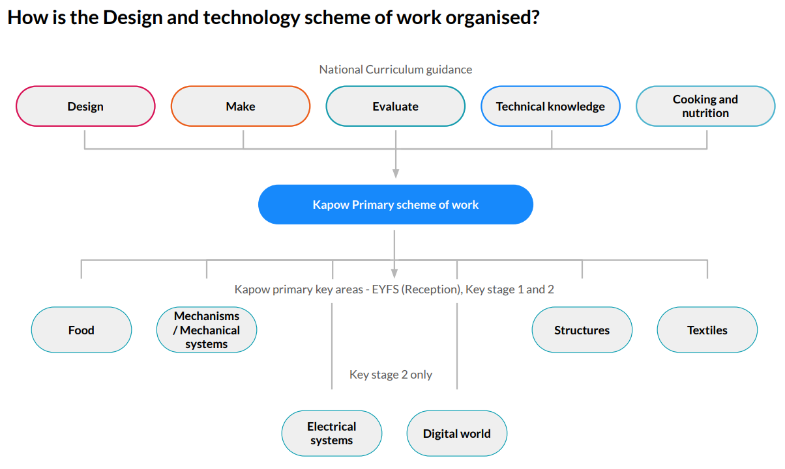

 | KS1 – fruit and vegetables |  | Y5/6 – what could be healthier?
Skills | Design |  | 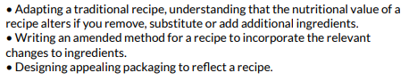
 | Make | 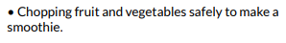 | 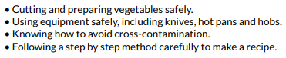
 | Evaluate | 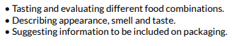 | 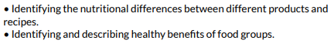
Knowledge | Cooking and  nutrition | 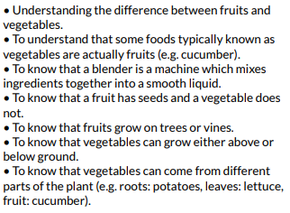 | 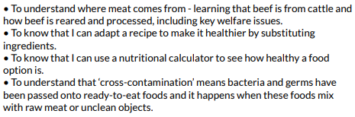
Food

Mechanisms/mechanical systems
 | KS1 – wheels and axles |  | Y5/6 – pop-up book
Skills | Design | 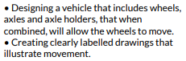 | 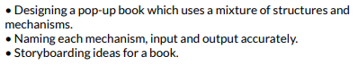
 | Make | 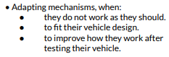 | 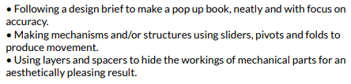
 | Evaluate | 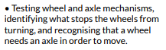
Knowledge | Technical | 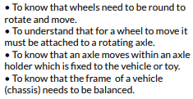 | 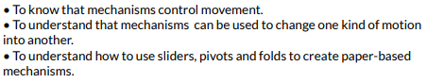
 | Additional | 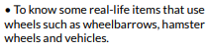 | 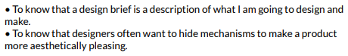

Electrical systems
 | Y3/4 - torches |  | Y5/6 – steady hand game
Skills | Design |  | 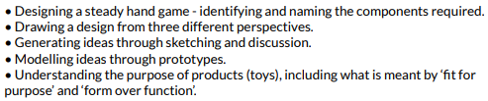
 | Make | 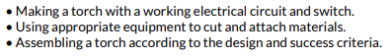 | 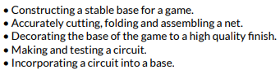
 | Evaluate | 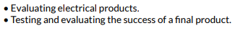 | 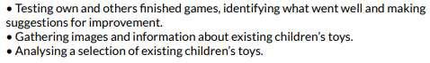
Knowledge | Technical | 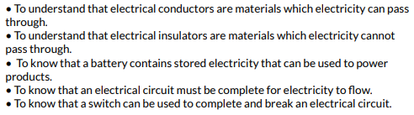
 | Additional | 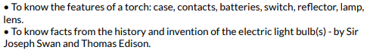 | 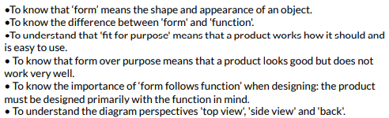

Structures
 | KS1 – constructing a windmill |  | Y3/4 – constructing a castle
Skills | Design | 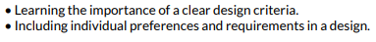 | 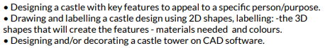
 | Make | 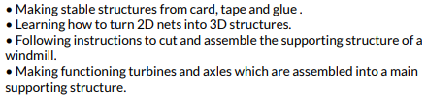 | 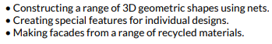
 | Evaluate | 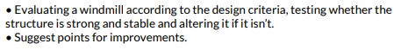 | 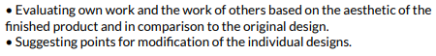
Knowledge | Technical | 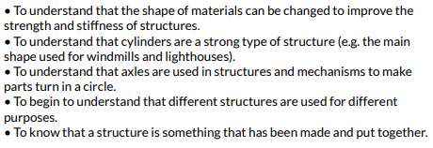
 | Additional | 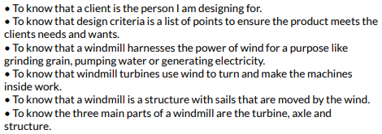 | 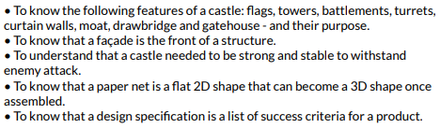

Textiles
 | Y3/4 - cushions
Skills | Design
 | Make | 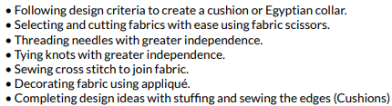
 | Evaluate
Knowledge |  | 