Tater Du sequence of learning – DT Year B

Spring term – Electrical systems: steady hand game
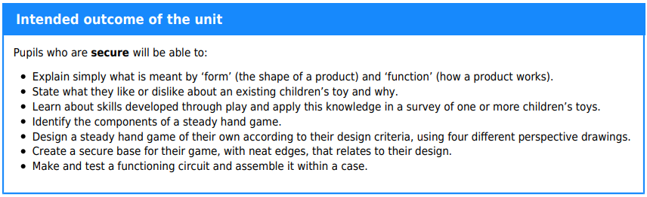
 | Key vocabulary
 | assemble  battery  battery pack  benefit  bulb  bulb holder |  | buzzer  circuit  circuit symbol  component  conductor  copper |  |  | design  design criteria  evaluation  fine motor skills  fit for purpose  form |  | function  gross motor skills  insulator  LED  user
Lesson 1 |  | Lesson 2 |  | Lesson 3 | Lesson 4
Lesson 1: Developing through play |  | Lesson 2: Game plan |  | Lesson 3: Base building | Lesson 4: Electronics and assembly
To research and analyse a range of children's toys |  | To design a steady hand game |  | To construct a stable base | To assemble electronics and complete an electronic game

