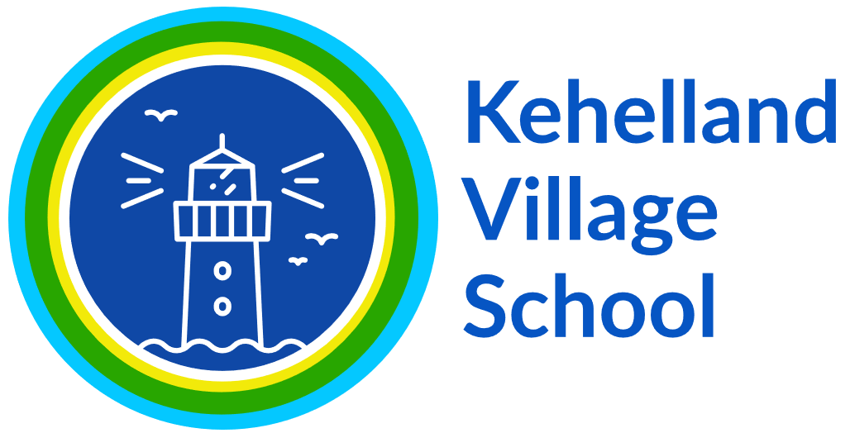
Subject Rolling Programme - Science

 | Autumn | Spring | Summer
EYFS | Overarching themes: Toys past and present/  Mining , Farming and Fishing/ Creepy Crawlies/  Mexico  Activities: Pirates- Treasure hunt  The Gruffalo- Animal homes  Art using natural materials.  Leaf rubbings, collage and prints.  Stick Man – Making stick characters.  Percy the Park keeper – tidying the environment.  Den building. Camp fire.  Signs of Autumn. | Overarching themes: Kings, Queens and Castles/  Where We Live/ Homes and Houses/ People who Help Us/ Villages and Cities  Activities: The Gruffalo’s Child- Shadows, baby animals, tracks.  Superworm- measuring, spider webs.  Signs of Winter.  Room on the Broom  Animal groups  Mud  Signs of spring.  Seeds and planting.  Signs of Spring. | Growing Plants/At the Seaside/Where we Live/Exploring Sea, Space and Land  Activities: We’re Going on a Bear Hunt- exploration.  Henry the explorer – map making and flag planting.  Bug hunt.  Signs of Spring/Summer  Rainbow flowers- Collecting colours. Flower prints.  Floating and sinking. Building waterways.  Den building. Camp fire.  Signs of Summer.
Year 1/2 (22-23) | Animals including humans Y1  Seasonal Change Y1 (ongoing)  Everyday materials Y1 | Plants Y1  Seasonal Change y1 (Ongoing) | Living Things and Their Habitats Y1  Science enquiry (Child led)
Year 1/2 (23-24) | Seasonal Change (Weather focus)  Science Enquiry (Child led)  Animals Including Humans Y2 | Use of Everyday Materials Y2  Seasonal Change y2 | Plants Y2  Living Things and their Habitats Y2
Year 3/4 (22-23) | Animals Including Humans Y3  Rocks Y3 | Light Y3  Forces and Magnets Y3 | Science Enquiry (child led)  Plants Y3
Year 3/4 (23-24) | Electricity Y4  Sound Y4 | Living Things and their Habitats Y4  States of Matter Y4 | Animals Including Humans Y4  Science Enquiry (child led)
Year 5/6 (22-23) | Earth and Space Y5  Properties and Changes of materials Y5 | Forces Y5  Living things and Habitats Y5 | Animals Including Humans Y5  Science Enquiry (child led)
Year 5/6 (23-24) | Living things and their Habitats Y6  Animals Including Humans Y6 | Evolution and Inheritance Y6  Electricity Y6 | Light Y6  Science Enquiry (child led)

