Tater Du sequence of learning – History Year B

Autumn term 1
How has crime and punishment changed over time in Britain?
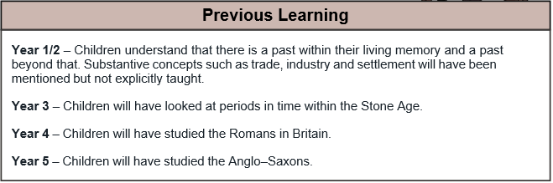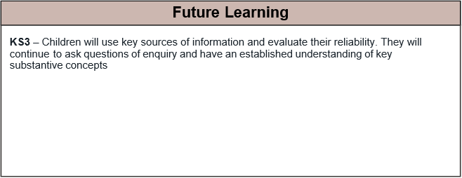
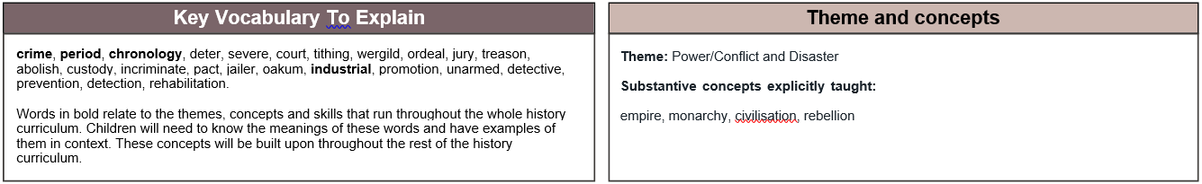

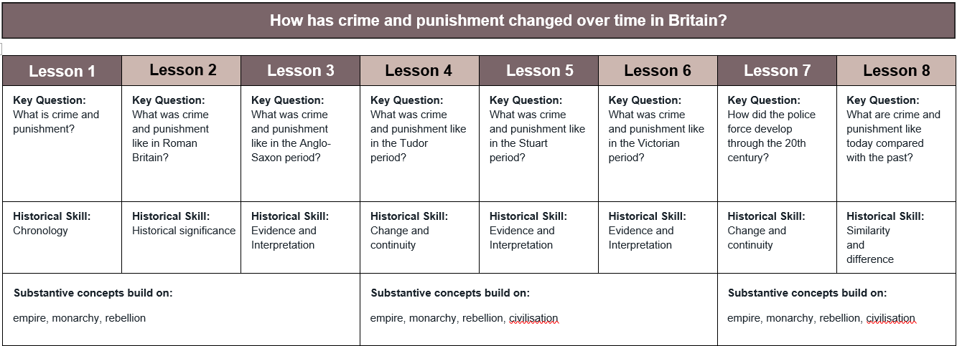

Autumn term 2
Why was the Battle of Britain a significant turning point for the United Kingdom in World War Two?
