Tater Du sequence of learning – PE Year B
Autumn term – orienteering
Cross-curricular orienteering Physical Education OAA Year 3
Lesson 1 | Lesson 2 | Lesson 3 | Lesson 4 | Lesson 5 | Lesson 6
Classic point-to-point orienteering 1 | Classic point-to-point orienteering 2 | Classic point-to-point orienteering 3 | Classic point-to-point orienteering 4 | Classic point-to-point orienteering 5 | Designing a point-to-point orienteering course

Autumn term – realPE
Year 5/6 unit 1
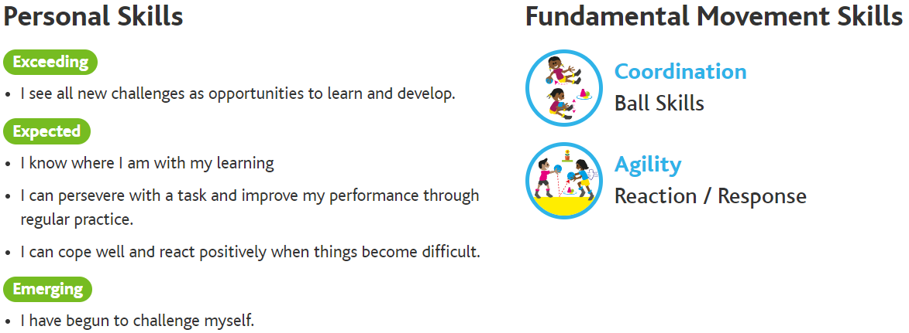

Lesson 1 | Lesson 2 | Lesson 3 | Lesson 4 | Lesson 5 | Lesson 6
Ball skills – stand with legs apart and move a ball around my legs and waist, in 20 seconds or less complete 12 figure of eight circuits using both hand | Reaction/response – start close to your partner and take up a ready position, from 1 metre react and catch a small ball after 1 bounce across your body | Ball skills – stand with legs apart and move a ball around my legs and waist, in 20 seconds or less complete 12 figure of eight circuits using both hand, in 20 seconds or less complete 20 front to back catches with a bounce in between | Reaction/response – start close to your partner and take up a ready position, from 1 metre react and catch a small ball after 1 bounce across your body, react to a call from your partner when they drop a ball then tunr and catch it after 1 bounce. | Ball skills– stand with legs apart and move a ball around my legs and waist, in 20 seconds or less complete 12 figure of eight circuits using both hand, in 20 seconds or less complete 20 front to back catches with a bounce in between, in 20 seconds or less complete 12 ‘long circles’ | Competition – round robins

Year 5/6 unit 2
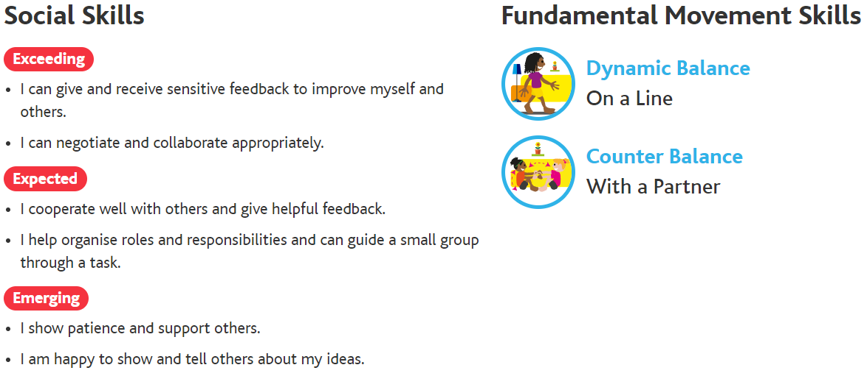

Lesson 1 | Lesson 2 | Lesson 3 | Lesson 4 | Lesson 5 | Lesson 6
Dynamic balance on a line – move along the line lifting your knees and driving your arms, walk fluidly on a line lifting heel to bottom knees up and heel to toe landing | Counter balance with a partner – hold with both hands and both feet touching, stand on 1 leg holding with 1 hand lean back hold balance then move back together | Dynamic balance on a line – move along the line lifting your knees and driving your arms, walk fluidly on a line lifting heel to bottom knees up and heel to toe landing, maintaining balance on a line sidestep in both directions | Counter balance with a partner – hold with both hands and both feet touching, stand on 1 leg holding with 1 hand lean back hold balance then move back together, with eyes closed and on 1 leg hold with 1 hand lean back balance then move together | Dynamic balance on a line – move along the line lifting your knees and driving your arms, walk fluidly on a line lifting heel to bottom knees up and heel to toe landing, maintaining balance on a line sidestep in both directions, maintaining balance on a line lunge walk backwards | Competition – round robins

Autumn term – realgym
Y5/6 unit 1
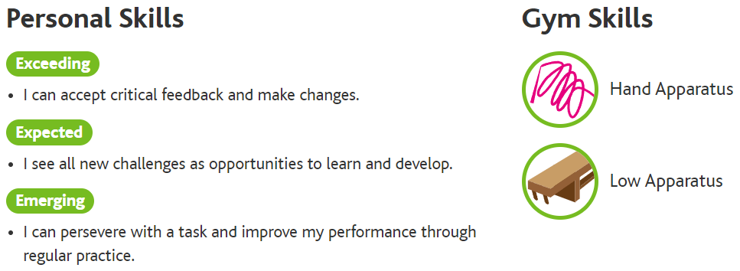

Lesson 1 | Lesson 2 | Lesson 3 | Lesson 4 | Lesson 5 | Lesson 6
Hand apparatus | Hand apparatus | Hand apparatus | Low apparatus | Low apparatus | Low apparatus

